**In this lecture notes, students will learn about the:**

* 4-bit Binary Parallel Adder-Subtractor
* Its Circuit Diagram and Working

**So, at the end of this lecture, students would be able to understand how 4-bit Binary Parallel Adder-Subtractor works.**

**4-Bit Binary Parallel Adder-Subtractor**

 **KIET GROUP OF INSTITUTIONS GHAZIABAD** 

**(An ISO – 9001: 2008 Certified & 'A' Grade Accredited Institution by NAAC)**

**4-BIT BINARY PARALLEL ADDER-SUBTRACTOR**

**What is 4-bit Binary Parallel Adder-Subtractor?**

It is a combinational circuit that can perform both addition and subtraction using one common circuit. Let’s try to understand its complete working using the circuit diagram shown below. This circuit requires prerequisite knowledge of Ex-OR Gate, and Binary Subtraction using 2’s complement. The circuit also consists of 4 full adders (FA) since we are performing operations on 4-bit numbers. There is a control line M that holds a binary value of either 0 or 1 which determines that the operation is carried out in addition or subtraction.

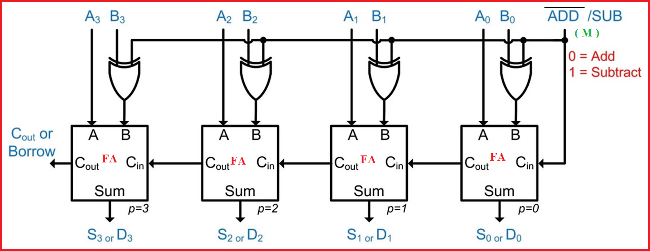

**Figure 1:** **4-Bit Binary Parallel Adder-Subtractor**

**Working of 4-Bit Binary Parallel Adder-Subtractor**

To understand the complete working of 4-Bit Binary Parallel Adder-Subtractor, students should first know about the concepts of subtraction i.e. how it can be done by using 2's complement. So, subtraction of binary numbers can be done most conveniently using complements.

**Let’s try to understand this using an example:**

A-B can be done by taking **“the 2’s complement of B and adding it to A”.**

Now, let’s try to understand “**how we can take 2’s complement of B**”.

The 2’s complement can be obtained by taking the 1’s complement of B and adding one to the least significant pair of bits. The 1’s complement can be implemented with inverters and a one can be added to the sum through the input carry.

 **KIET GROUP OF INSTITUTIONS GHAZIABAD** 

**(An ISO – 9001: 2008 Certified & 'A' Grade Accredited Institution by NAAC)**

In 4-Bit Binary Parallel Adder-Subtractor, the addition and subtraction operations can be combined into one common circuit by including an **exclusive-OR(XOR) gate with each full-adder**. So, next, try to understand the concept of the XOR gate which is explained in the below figure.

**The Concept of Exclusive-OR Gate (XOR)**

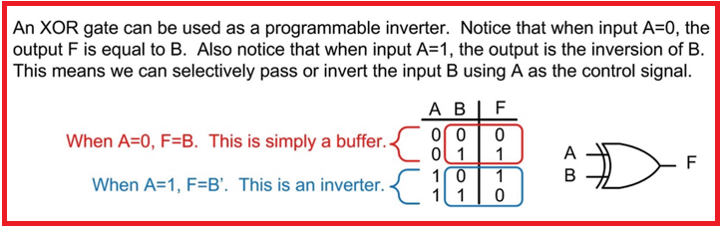

**Figure 2: XOR Gate**

A 4-bit binary parallel adder-subtractor is shown in figure 1. The mode input M or [ADD’/SUB] controls the operation. When M=0 the circuit is an adder and when M=1 the circuit becomes a subtractor. Each exclusive-OR gate receives input M and one of the inputs of B. When M=0, we have BꚚ0=B. The full adders receive the value of B, the input carry is 0, and the circuit performs A plus B. When M=1, we have BꚚ1=B’ and C0=1. The B inputs are all complemented and a 1 is added through the input carry. The circuit operates A plus the 2's complement of B. This is nothing but A-B.

For unsigned numbers, this gives A-B if A≥B or the 2’s complement of (B-A) if A<B.

For a signed number, the result is A-B provided that there is no overflow.